|  |  |
| --- | --- |
| Country | **Palestine** |
| Project name | **Monitoring of Sustainable Development Goals Indicators** |
| Implementing Agency | **Istat – Italian National Institute of statistics** |
| Partner Institution | **PCBS - Palestinian Central Bureau of Statistics** |

**Management of the SDG indicators**

**Web Application (WA)**

REFERENCE GUIDE

Date: 22/07/2019

Doc. Version: 2nd Draft

**Document Information**

|  |  |
| --- | --- |
| **Settings** | **Value** |
| **Document Title:** | Web Application (WA)  REFERENCE GUIDE |
| **Project Component/Activity** | Component 2: Development of SDGs Databases/Activity 2.1: Support for the development of a web application for SDGs data production |
| **Document Authors:** | Guido Drovandi, Sonia Scialanca, Francesco Amato |
| **PCBS Counterpart:** | Mohammed Sahmoud (IT expert) |
| **Doc. Version:** | 2nd Draft |
| **Sensitivity:** | PUBLIC |
| **Date:** | 22/07/2019 |

**Index**

*1. INTRODUCTION* 3

*2. PURPOSE OF THE WEB APPLICATION* 3

*3. USING THE WEB APPLICATION* 4

*4. DATABASE SCHEMA ………………………………………………………………………….………………………………………………..…………………...* 12

*5. MDT2PxWeb……………………………………………………………………………………….………………………………………………..…………………..* 14

# 1. INTRODUCTION

This document draw on the work carried out up to March and July 2019 under Component 2 “Development of SDGs Databases” of the project in Palestine “Monitoring of Sustainable Development Goals Indicators - SDGs” funded by the Italian Agency for Development Cooperation (AICS) and implemented by the Italian National Institute of Statistics (Istat) with the aim to provide technical support to the Palestinian Central Bureau of Statistics (PCBS) for building up the national system of SDG indicators.

The document is to be used as a guide to understanding the main features of the Web Application (WA) jointly developed by PCBS and Istat IT experts in order to streamline and improve the SDGs data and metadata management process.

It includes written and visual information to assist PCBS statisticians (including the staff responsible of sub-indicators, i.e. PCBS indicators) in completing tasks associated with the usage of the WA.

# 2. PURPOSE OF THE WEB APPLICATION

A Web Application is an application software stored on a remote server and delivered over the web through a browser interface. In this case, the WA is installed for local purposes, so it is only available to users of the PCBS Intranet, after a proper authentication.

The WA, developed by PCBS and Istat IT experts, allows a generalized management of indicators and sub-indicators, that have the same structure as the SDGs indicators.

In this document we will talk generically about SDGs indicators and SDGs_WA application.

The SDGs_WA provides a number of functionalities that help the system of SDG indicators runs more smoothly, reducing the manual effort in the management of data and metadata and the possibilities of human error with controlled flows and error checks.

It enables PCBS statisticians to focus only on data and metadata of a single goal/indicator/sub-indicator and to work in cooperative way.

The WA allows to:

* create new SDGs sub-indicators selecting theirs dimensions
* update SDGs sub-indicators metadata
* download an SDGs sub-indicators data Excel template
* upload SDGs sub-indicators’ data to the MDT database through the Excel files or the WA interface
* monitor the data upload status of a sub-indicator
* improve security
* restrict access to the data based on PCBS department groups
* monitor data managers

The application software has been installed in the PCBS production infrastructure.

# 3. USING THE WEB APPLICATION

**Instructions for managing metadata and data**

To access the main page a user must login with his own credentials:

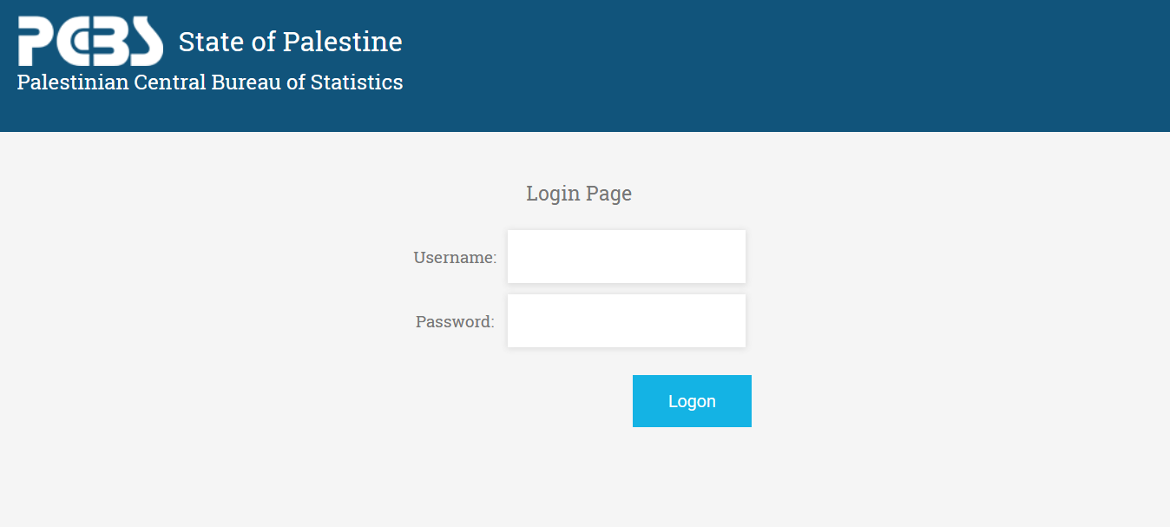

From the home page the user will see only the goals allowed, based on his role and membership in departments:

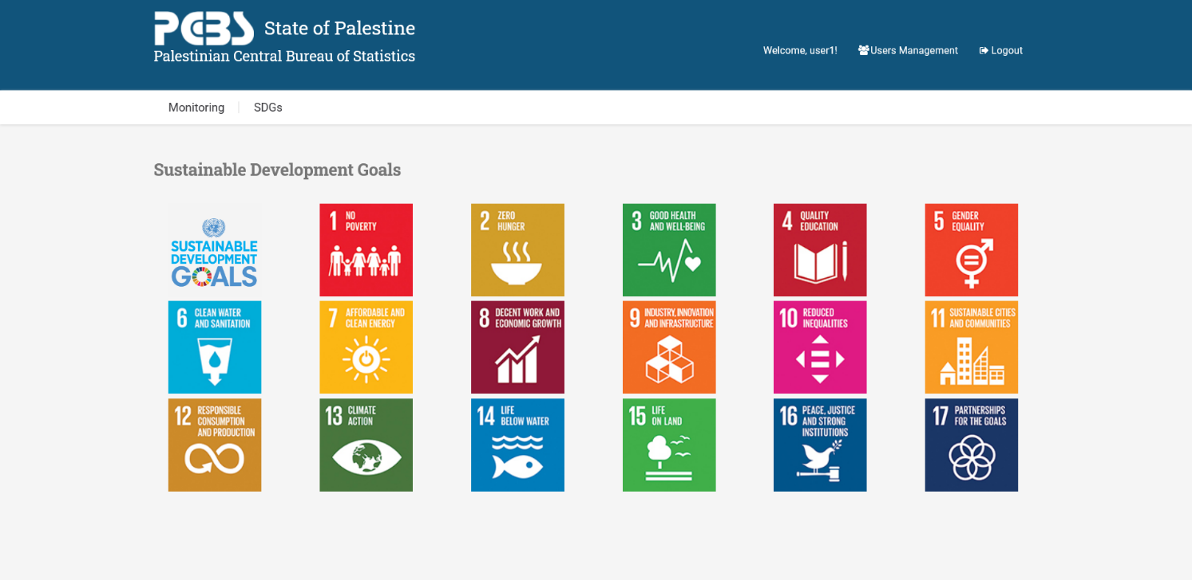

In this page, the user can, also, choose the type of indicators.

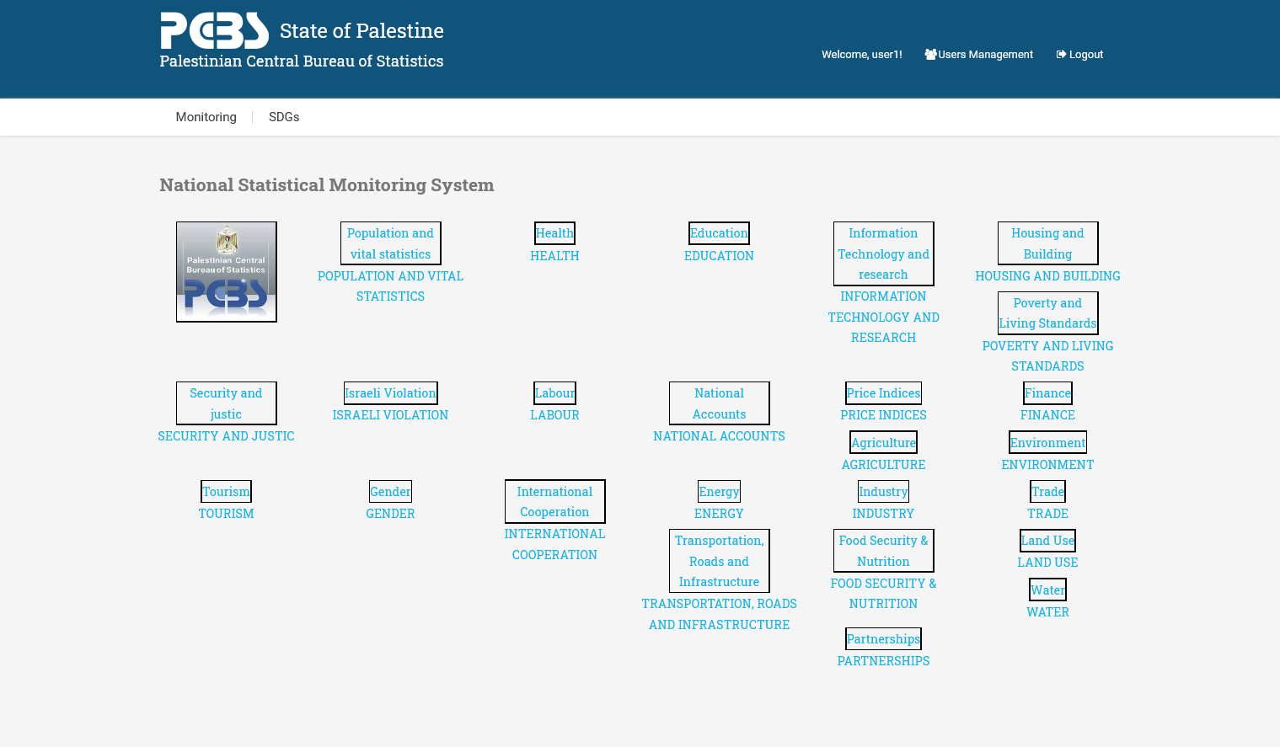

After selecting a goal, the list of related targets and indicators is shown.

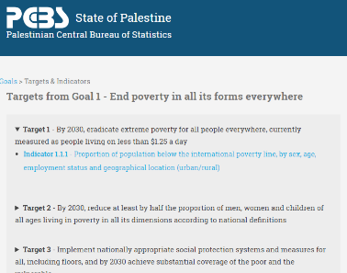

Selecting one indicator, the list of its sub-indicators is shown.

From this list of sub-indicators it is possible to:

1. **MODIFY THE METADATA**: at the moment only the descriptions in English and Arabic languages are considered, in the future it will be possible to add new metadata.

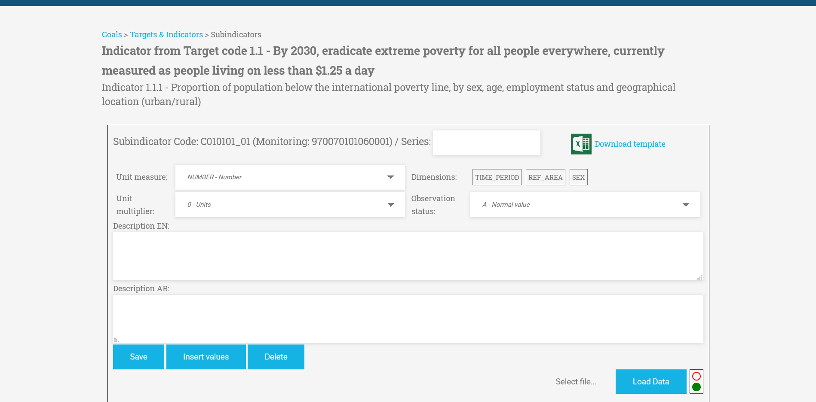

1. **INSERT DATA**: it is allowed to download the Excel template of the selected sub-indicator by clicking on the “Template” button: the Excel template is already filled with all the possible combinations of the dimensions of the selected sub-indicator and the metadata about goal, target, indicator and sub-indicator.

For indicators and sub-indicators, common to several types of systems, the SDGs_WA shows all the relative original codes in the various systems.

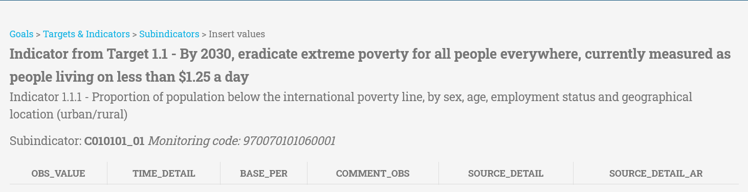

After downloading the template file, the responsible of the selected sub-indicator can insert the data and upload the file to the MDT database using the “Load Data” functionality of the Web Application. A traffic light turns green when the data is loaded properly. This allows the users to monitor the status of the sub-indicator data.

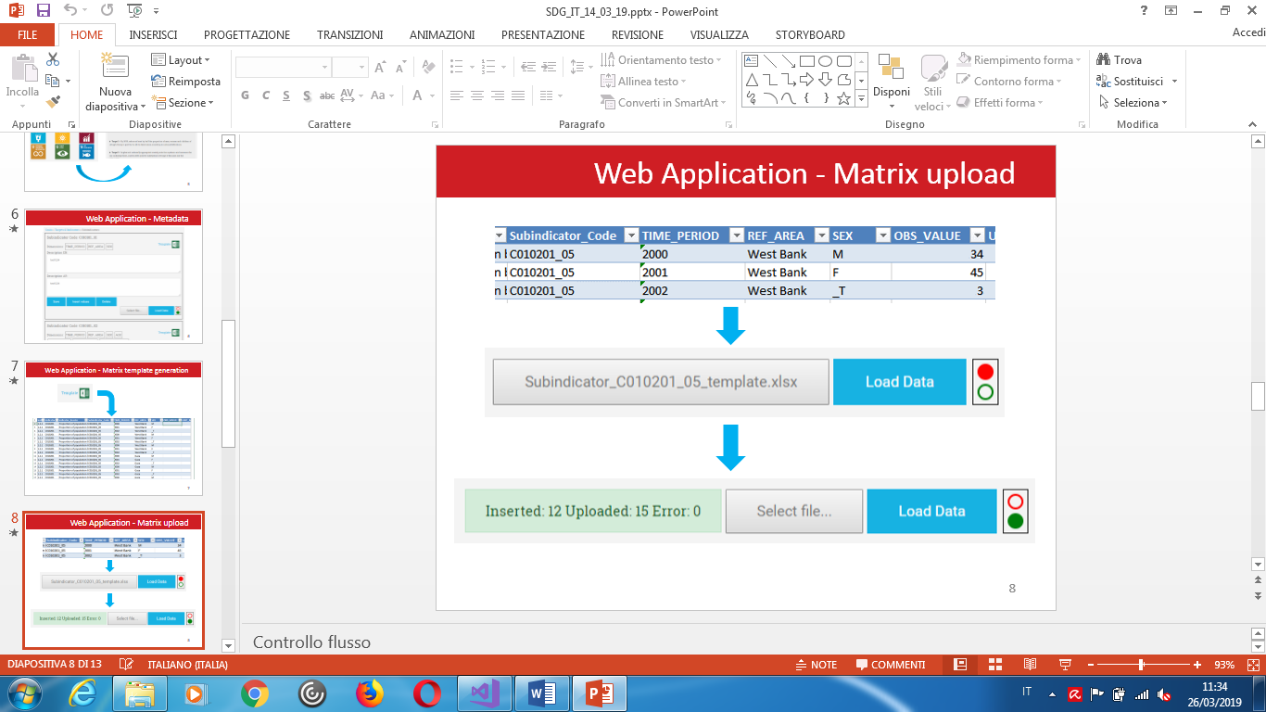

As an alternative, the responsible of the sub-indicator can insert data from the Web Application using the functionality “Insert Data”.

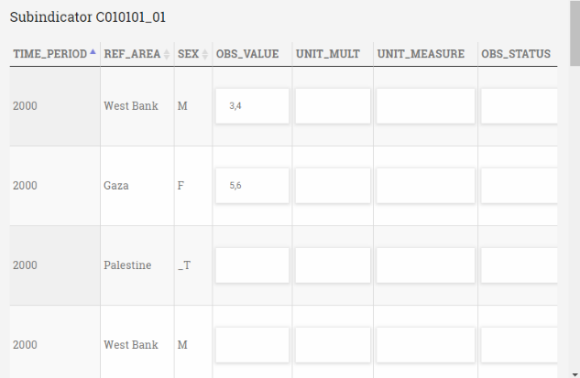

1. **LINK A SUB-INDICATOR TO AN SDG INDICATOR**: Using the functionality “Add new subindicator”, an user can link a PCBS indicator (sub-indicator) to an SDG indicator. For this sub-indicator it is possible to insert the descriptions and to select its dimensions (at least one dimension is required).

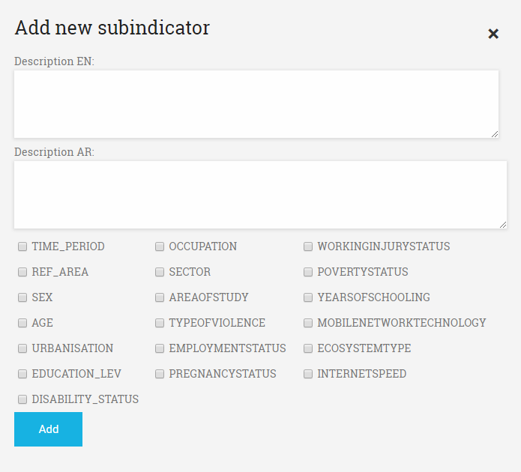

**Administrator functionalities**

If the logged in user has an administrator role, he can monitor and manage the list of the authorized users:

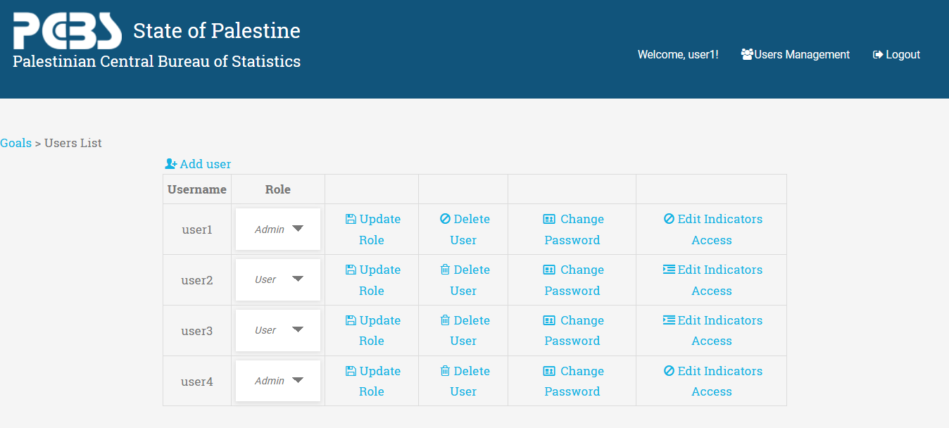

From this dashboard the administrator can:

1. **ADD USERS**: by clicking on the link at the left-top position “*Add User*”, a new user can be added to the list. The administrator must define a password and a role for him:

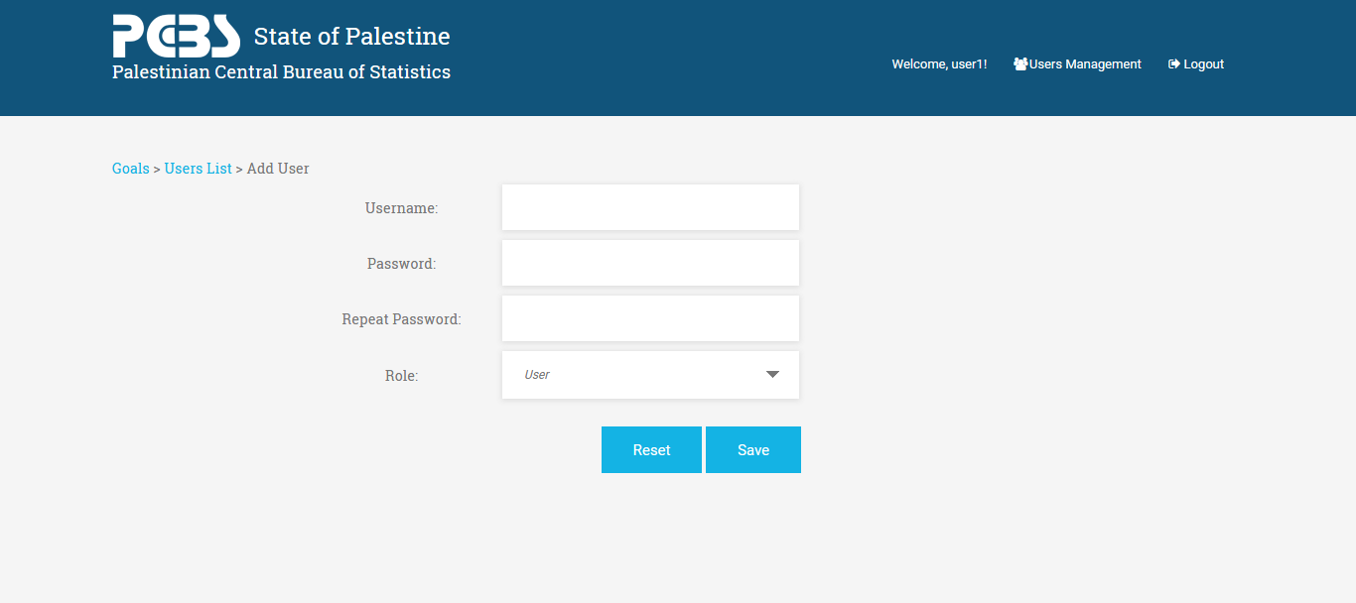

1. **DELETE USERS**: by clicking on the button link “Delete User”, the administrator can delete every user he wants, after confirming on the validation popup (he cannot delete himself).
2. **CHANGE ROLE**: by selecting the role in the option menu and clicking on the button link “Update Role”, the administrator can update a user role. If an Admin role is selected the user will have access to all the indicators automatically.
3. **CHANGE PASSWORD**: ad administrator could change the password of every user.

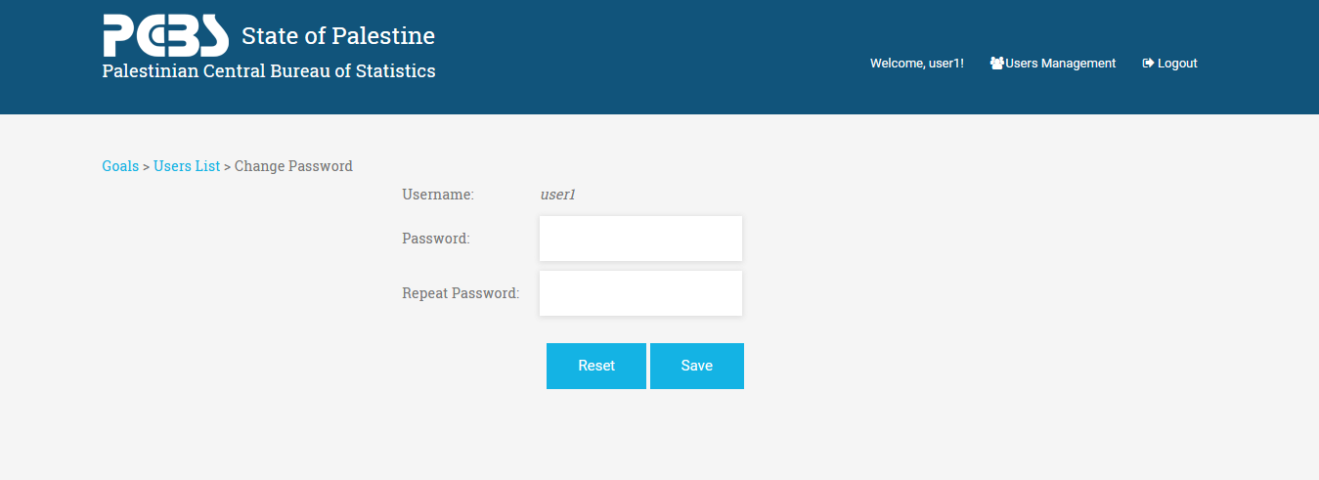

1. **EDIT INDICATORS ACCESS**: by clicking on the button link “Edit Indicators Access”, the administrator can choose the indicators that the selected user will see

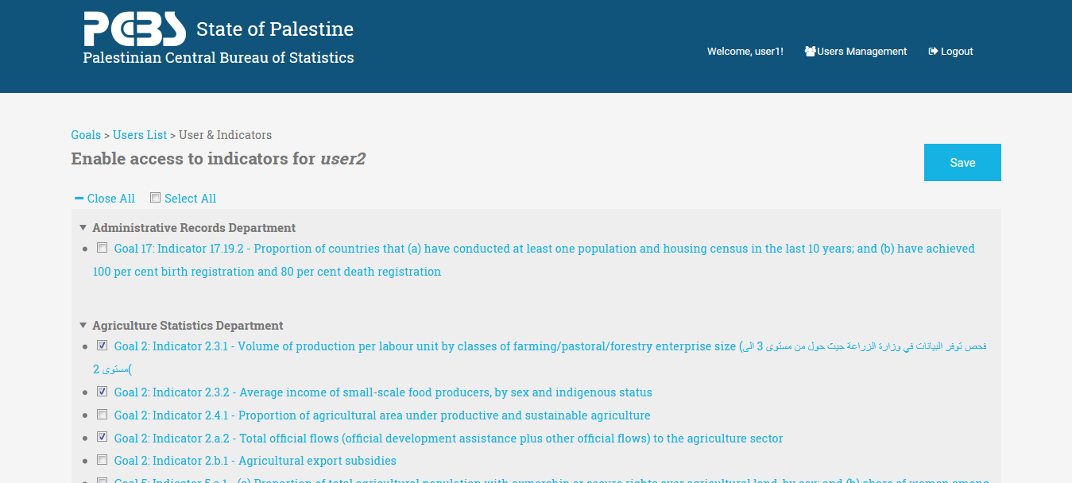

The 244 indicators are grouped by the 25 PCBS department:

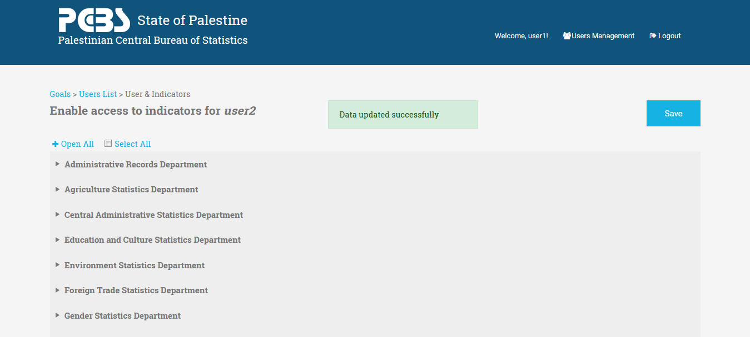

The administrator could select each indicator alternatively from the same or from different departments or he could select all the indicators belonging to a single department, depending on the topic the user is working on.

Thanks to this feature the administrators can easily control which user is responsible for which indicator.

**Non-admin users functionalities: change password**

A non-admin user can only change his own password:



He will not have access to any of the administrator features seen before.

# DATABASE SCHEMA

The web application interfaces with a SQL Server database. The schema of the tables is shown in the following images:

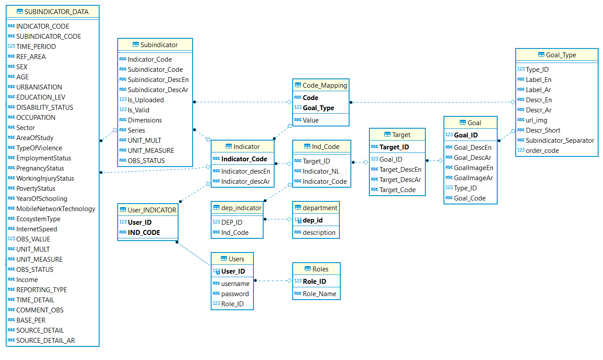

Database schema

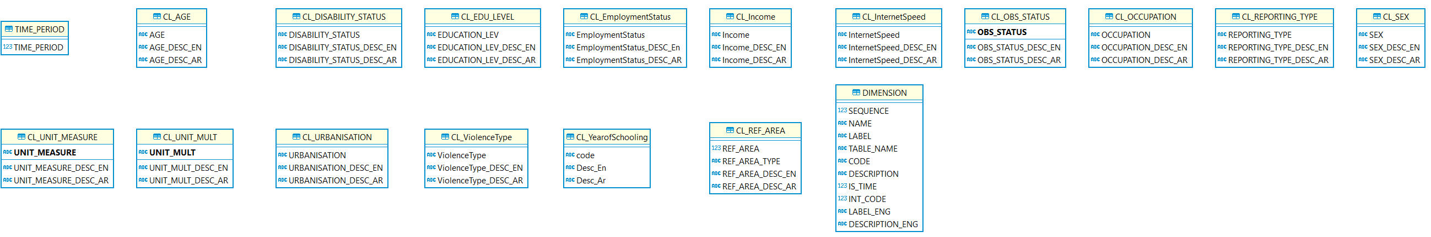

Classification’s tables

The main tables are described in the following table:

|  |  |
| --- | --- |
| **TABLE** | **Description** |
| GOAL | List of the goal |
| GOAL_TYPE | List of type of goal |
| TARGET | List of target |
| INDICATOR | List of indicators |
| IND_CODE | List of relationships between Target and Indicators |
| SUBINDICATOR | List of subindicators |
| TIME_PERIOD | List of time period |
| SUBINDICATOR_DATA | Multidimensional table contains subindicator’s data |
| CODE_MAPPING | List of labels of indicators and subindicators, by goal_type, that are displayed in web application. |
| DIMENSION | Classification’s list in SUBINDICATOR_DATA |
| CL_AGE | Classification in SUBINDICATOR_DATA |
| CL_DISABILITY_STATUS | Classification in SUBINDICATOR_DATA |
| CL_EDU_LEVEL | Classification in SUBINDICATOR_DATA |
| CL_EMPLOYMENTSTATUS | Classification in SUBINDICATOR_DATA |
| CL_INCOME | Classification in SUBINDICATOR_DATA |
| CL_INTERNETSPEED | Classification in SUBINDICATOR_DATA |
| CL_OBS_STATUS | Classification in SUBINDICATOR_DATA |
| CL_OCCUPATION | Classification in SUBINDICATOR_DATA |
| CL_REF_AREA | Classification in SUBINDICATOR_DATA |
| CL_REPORTING_TYPE | Classification in SUBINDICATOR_DATA |
| CL_SEX | Classification in SUBINDICATOR_DATA |
| CL_UNIT_MEASURE | Classification in SUBINDICATOR_DATA |
| CL_UNIT_MULT | Classification in SUBINDICATOR_DATA |
| CL_URBANISATION | Classification in SUBINDICATOR_DATA |
| CL_VIOLENCETYPE | Classification in SUBINDICATOR_DATA |
| CL_YEAROFSCHOOLING | Classification in SUBINDICATOR_DATA |
| USERS | List web application’s users |
| ROLES | List of roles of users (Admin, User) |
| DEPARTMENT | List of departments of Institute |
| DEP_INDICATOR | List of relationships between indicators and departments |
| USER_INDICATOR | List of users enabled for indicators |

# 5. MDT2PxWeb

MDT2PxWeb is a tool to export data and metadata from the SDGs_WA database to a PxWeb database, following the Nordic Data Model (CNMM) 2.3.

The tool can be run with the following commands:

1. create SDGs structure into the PxWeb database:

MDT2PxWeb conf.json [print [output.sql]]

1. update SDGs data into the PxWeb database

MDT2PxWeb conf.json update [output.sql]

If specified the *output.sql* file, the tool will also create a sql script file.

The file *conf.json* is a configuration file for the tool. Un example of configuration file is shown below:

{

"organizationCode": "PCBS",

"organizationName": "Palestinian Central Bureau of Statistics",

"goalType": "1",

"goalTypeLabel": "SDGs Indicators",

"userId": "SDGS",

"obsValue": "OBS_VALUE",

"mainLanguage": {

"code": "ar",

"suffixDB":"",

"labelValue": "ar: Sub Indicator",

"labelContent": "ar: Sustainable Development Goals - SDGs"

},

"secondaryLanguage": {

"code": "en",

"suffixDB":"ENG",

"labelValue": "Sub Indicator",

"labelContent": "Sustainable Development Goals - SDGs"

},

"mdtDb": {

"connectionString": "Server=localhost\\SQLEXPRESS;Database=SDGS;Trusted_Connection=True;",

"username": null,

"password": null,

"dimensionsTable": {

"name": "DIMENSION"

},

"dataTable": {

"name": "SUBINDICATOR_DATA",

"code": "SUBINDICATOR_CODE"

},

"goalTable": {

"name": "V_GOAL",

"id": "Goal_ID",

"code": "Goal_CODE",

"typeId": "Type_ID",

"desc": "Goal_DescAr",

"descEn": "Goal_DescEn",

"order": "Goal_ID",

"reference": "Type_ID"

},

"targetTable": {

"name": "V_TARGET",

"id": "Target_ID",

"code": "Target_Code",

"desc": "Target_DescAr",

"descEn": "Target_DescEn",

"reference": "Goal_ID"

},

"indicatorTable": {

"name": "V_INDICATOR",

"code": "Indicator_Code",

"codeValue": "Indicator_CodeValue",

"desc": "Indicator_descAr",

"descEn": "Indicator_descEn",

"reference": "Target_ID",

"reference1": "Goal_Type"

},

"subIndicatorTable": {

"name": "V_SUBINDICATOR",

"code": "Subindicator_Code",

"codeValue": "Subindicator_CodeValue",

"desc": "Subindicator_DescAr",

"descEn": "Subindicator_DescEn",

"dimensions": "Dimensions",

"reference": "Indicator_Code",

"reference1": "Goal_Type",

"reference2": "Target_ID",

"condition": "Is_Valid = 1"

}

},

"pxwebDb": {

"connectionString": "Server=localhost\\SQLEXPRESS;Database=pxweb_sdgs;Trusted_Connection=True;",

"username": null,

"password": null,

"dataTable": {

"name": "INDICATORDATA",

"code": "SUBINDICATOR_CODE"

}

}

}

To create and populate the PxWeb database, using the provided sql script files, you need to perform the following steps:

1. Run script *0_create_required_views.sql* into SDGs_WA database to create the necessary views;
2. Run script *1_init_PxWeb.sq*l into PxWeb database to create the Nordic Data Model tables;
3. Run script *2_populate_PxWeb.sql* into PxWeb database to load metadata;
4. Run script *3_indicatordata_SDGs_PxWeb.sql* into PxWeb database to load MDT indicators data;
5. Run *MDT2PxWeb* tools to populate the Nordic Data Model tables.